AAW

AWS ADVANCED ASSIGNMENT-5

DAY 11-12

ARAVIND G KUMAR

Task 1: Working with SNS

* Go to SNS home page.
* Click on topic.
* Create topic.
* Select standard type.
* Create subscription.
* Select the type and give email id.
* Give the confirmation.

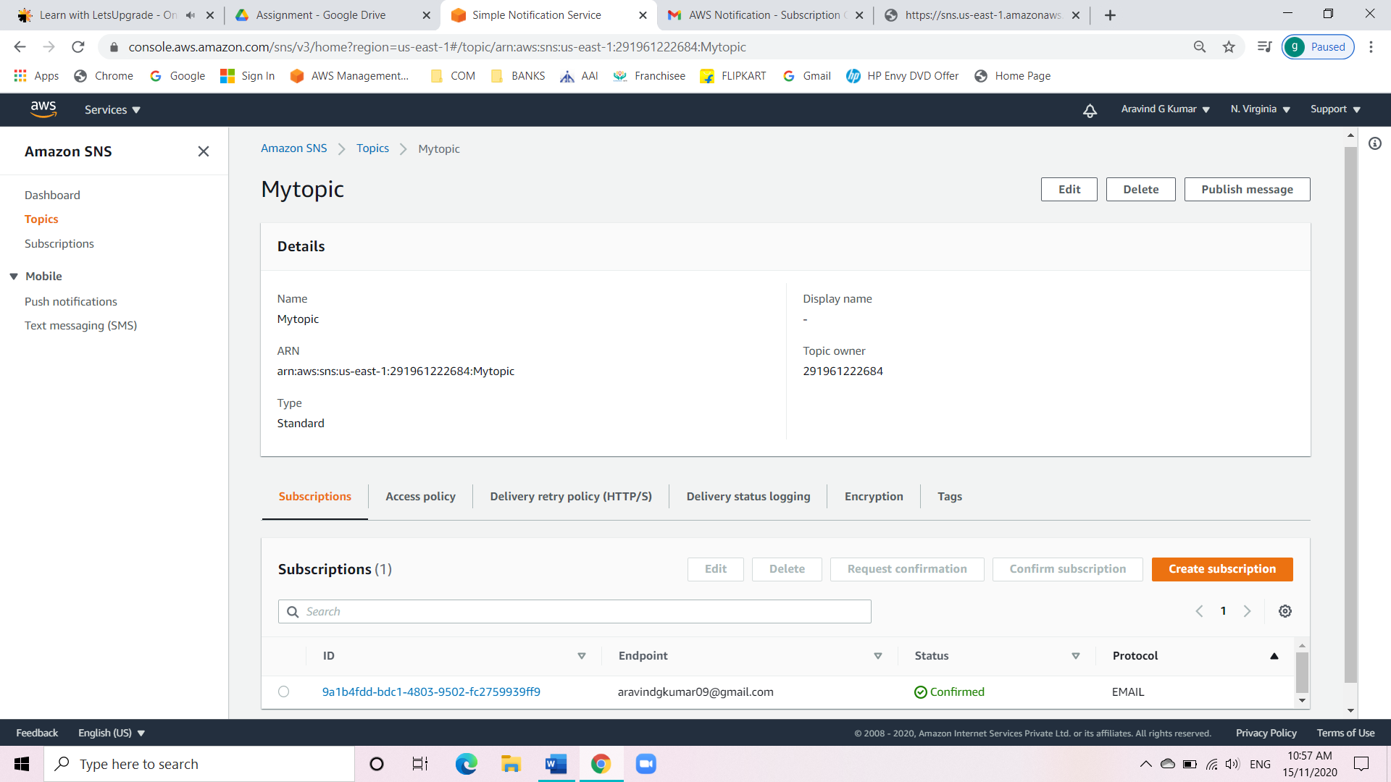

* Then click on publish message.
* Check whether the message has been reflected onto your email.

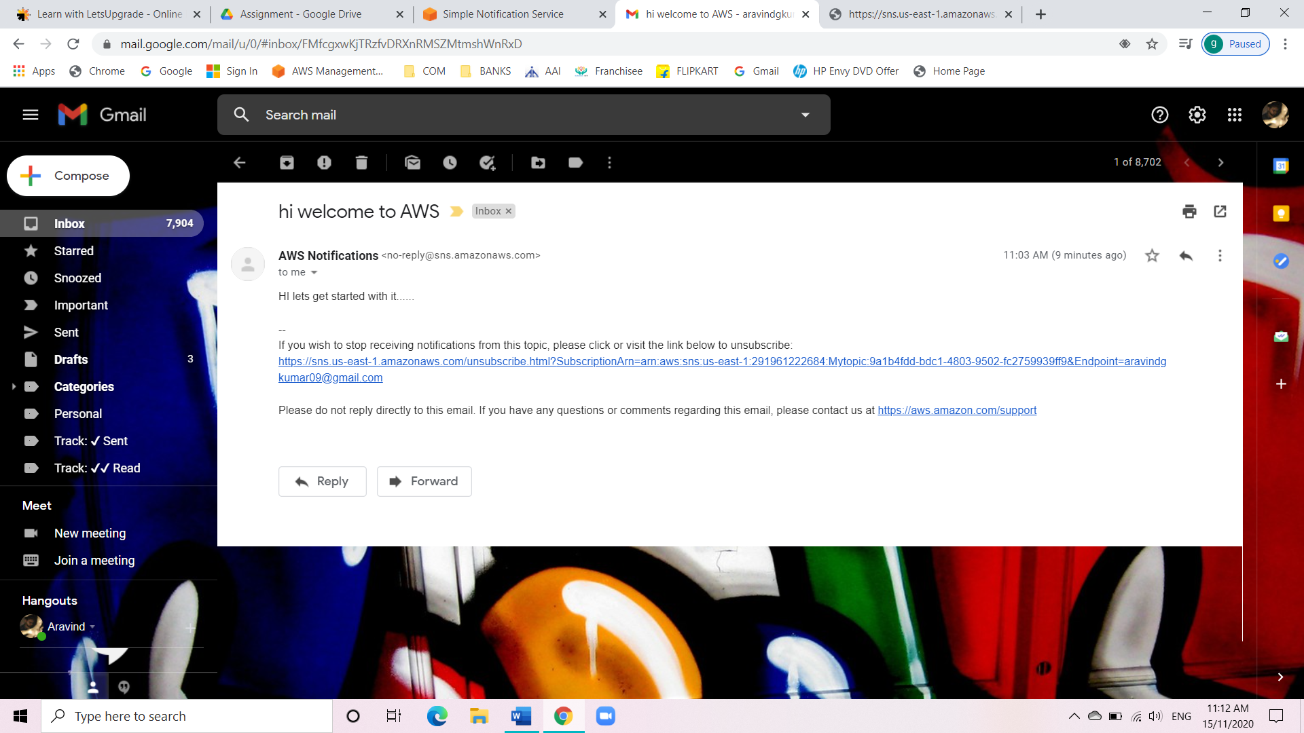

Task 2: Working with SQS

* Go to SQS home page.
* Create the queue.

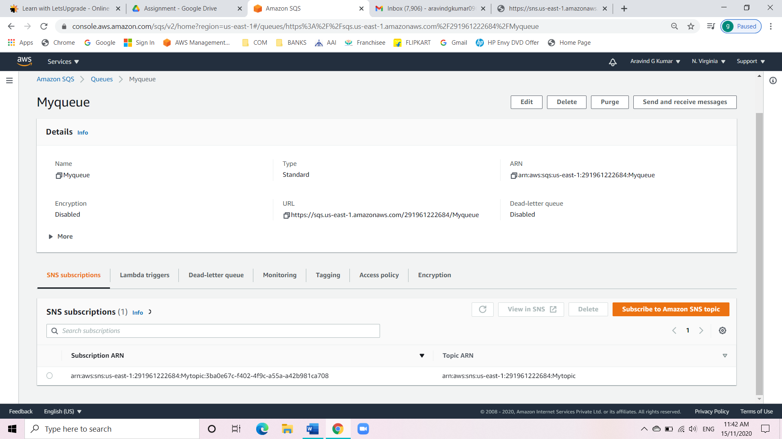

* After that poll for the message.

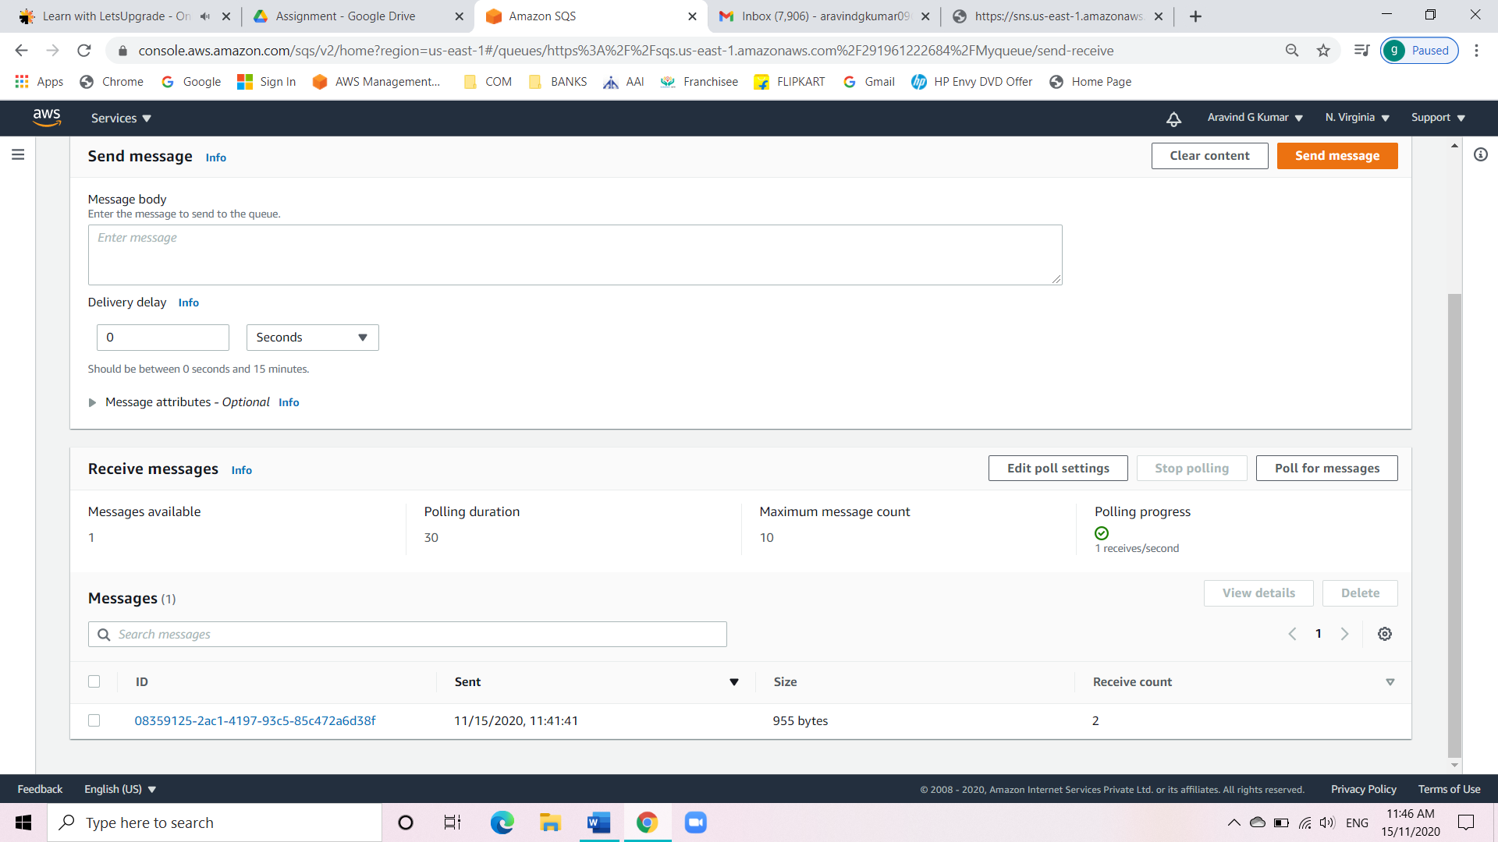

Task 3: Working with SES

* Go to SES home page.
* Click on email addresses.
* Add two new email id and verify them.

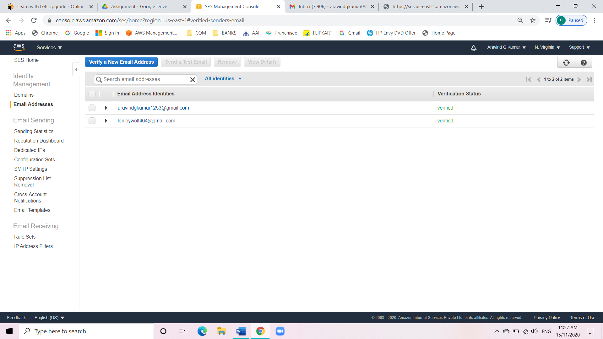

Task 4: Triggering CloudWatch Event SNS notification

* Go to SES home page.
* Verify the email.
* Create an EC2 instance.

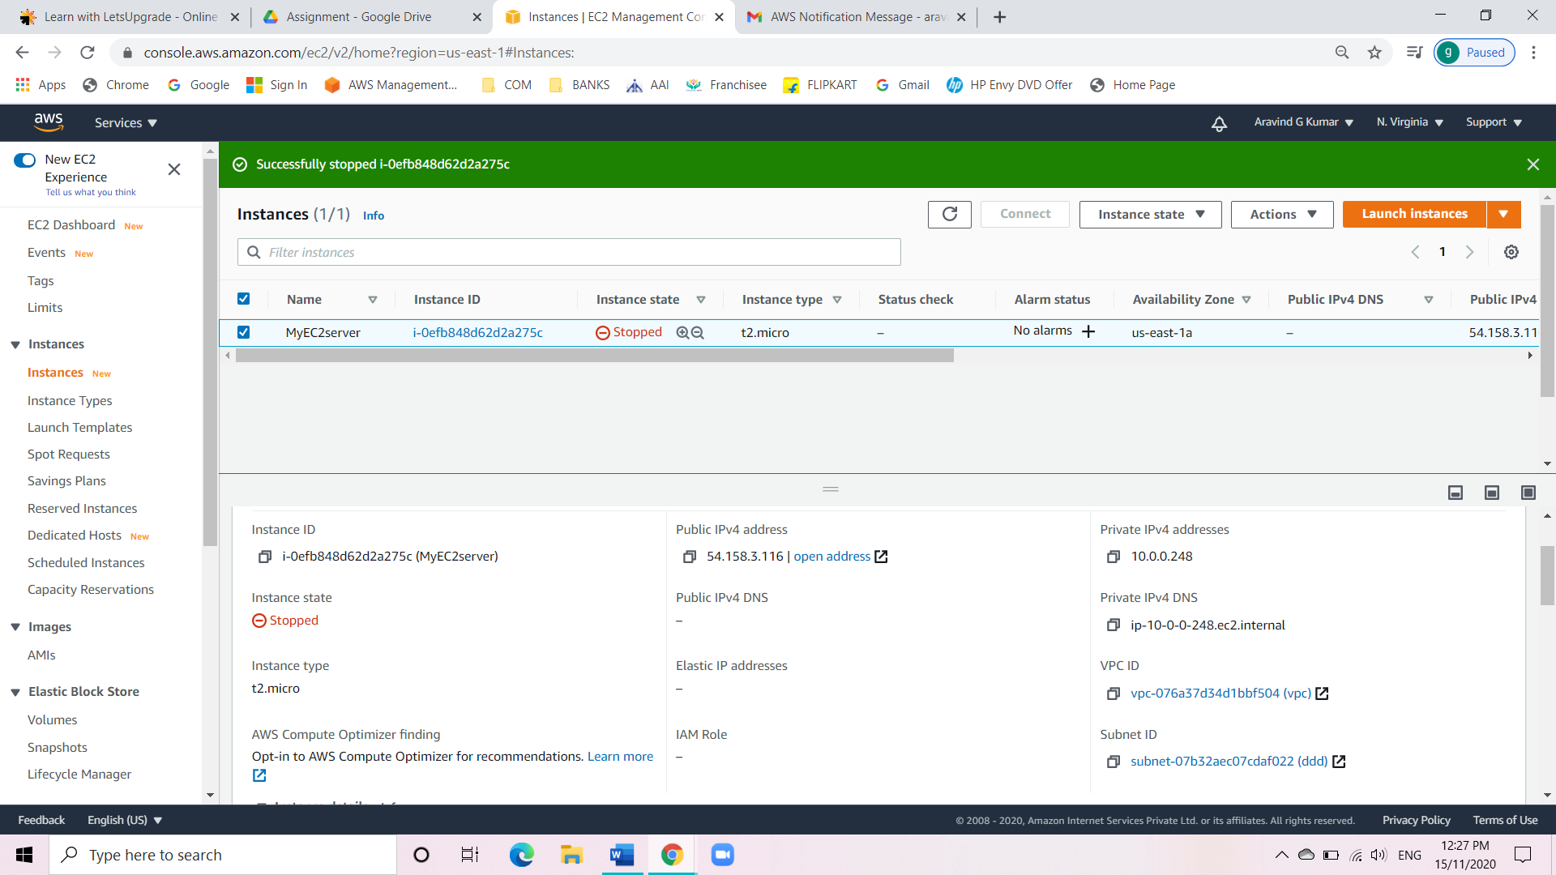

* Go to rules in SES page.
* Add the rule as EC2 state change.

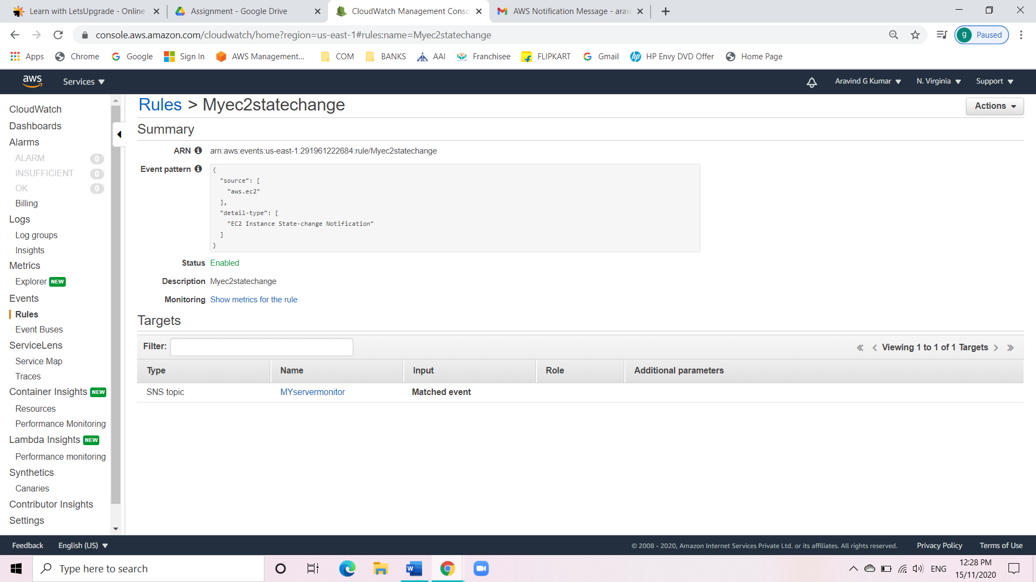

* Go to SNS topic to see the new rule created is reflecting there.

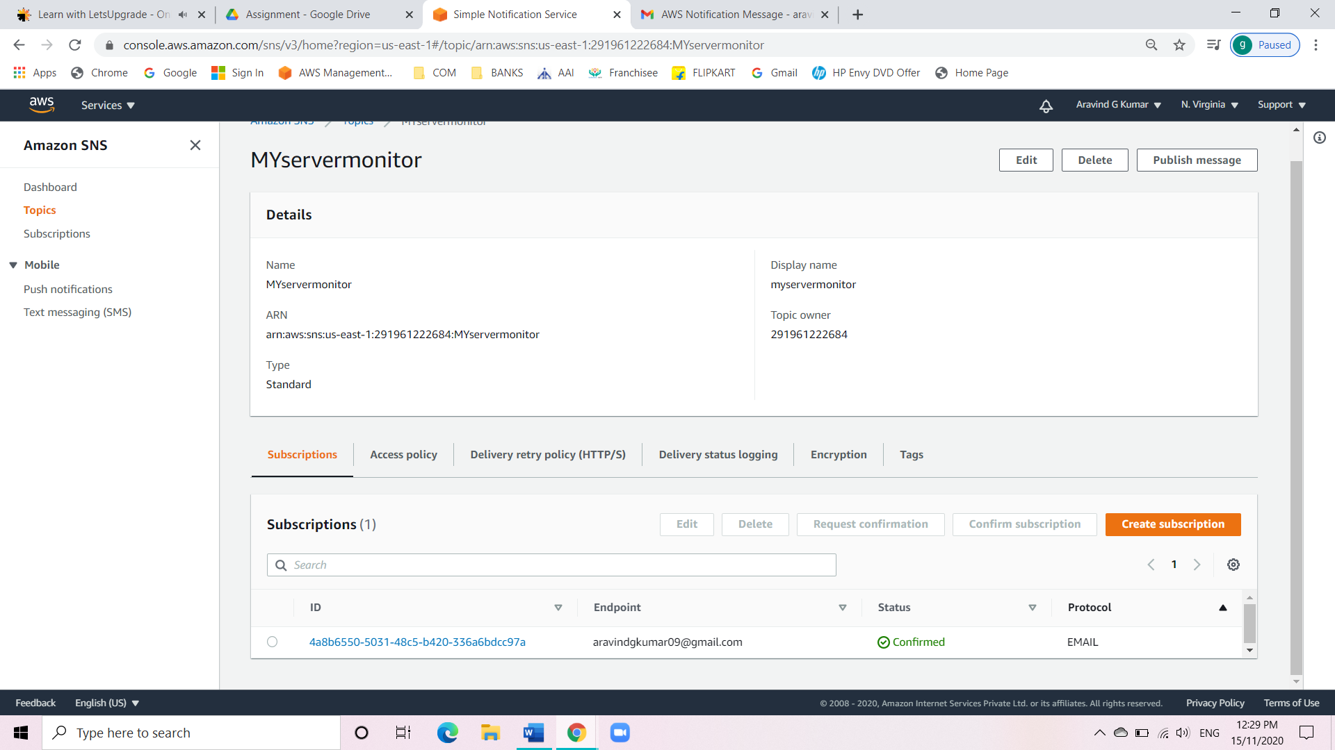

* Now change the states of the instances.

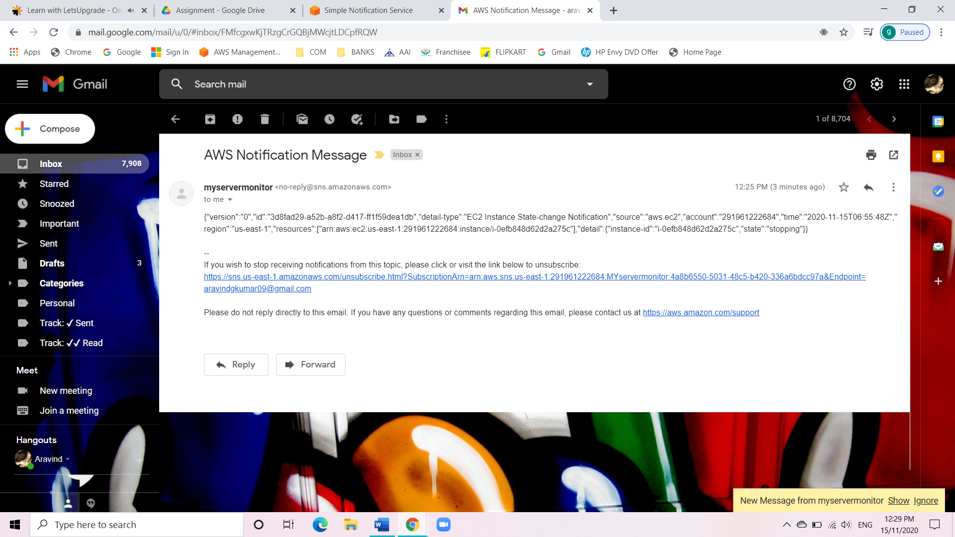

Task 5: Create a dynamo db table with minimum two disaster recovery zones and verify

replication.

* Go to dynamo DB homepage.
* Create a table.
* Give the names to the table.
* Manage streams and enable it.

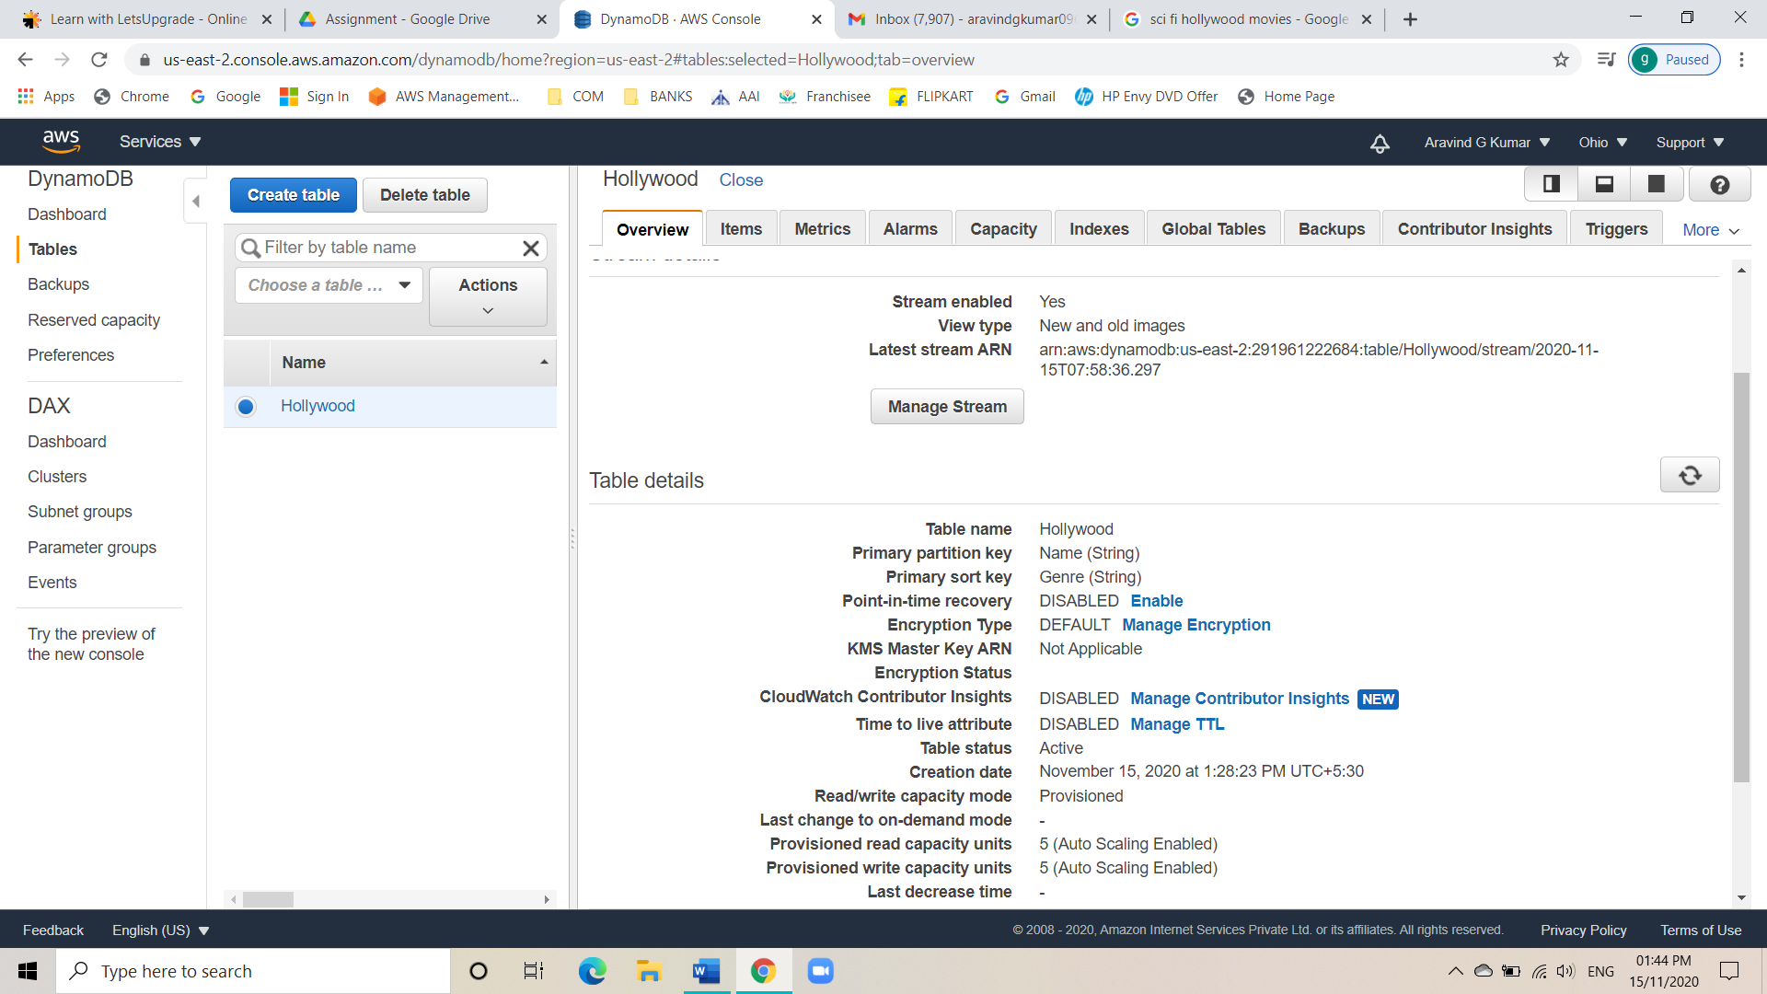

* Go to global tables.
* Choose two AZ which are far apart.

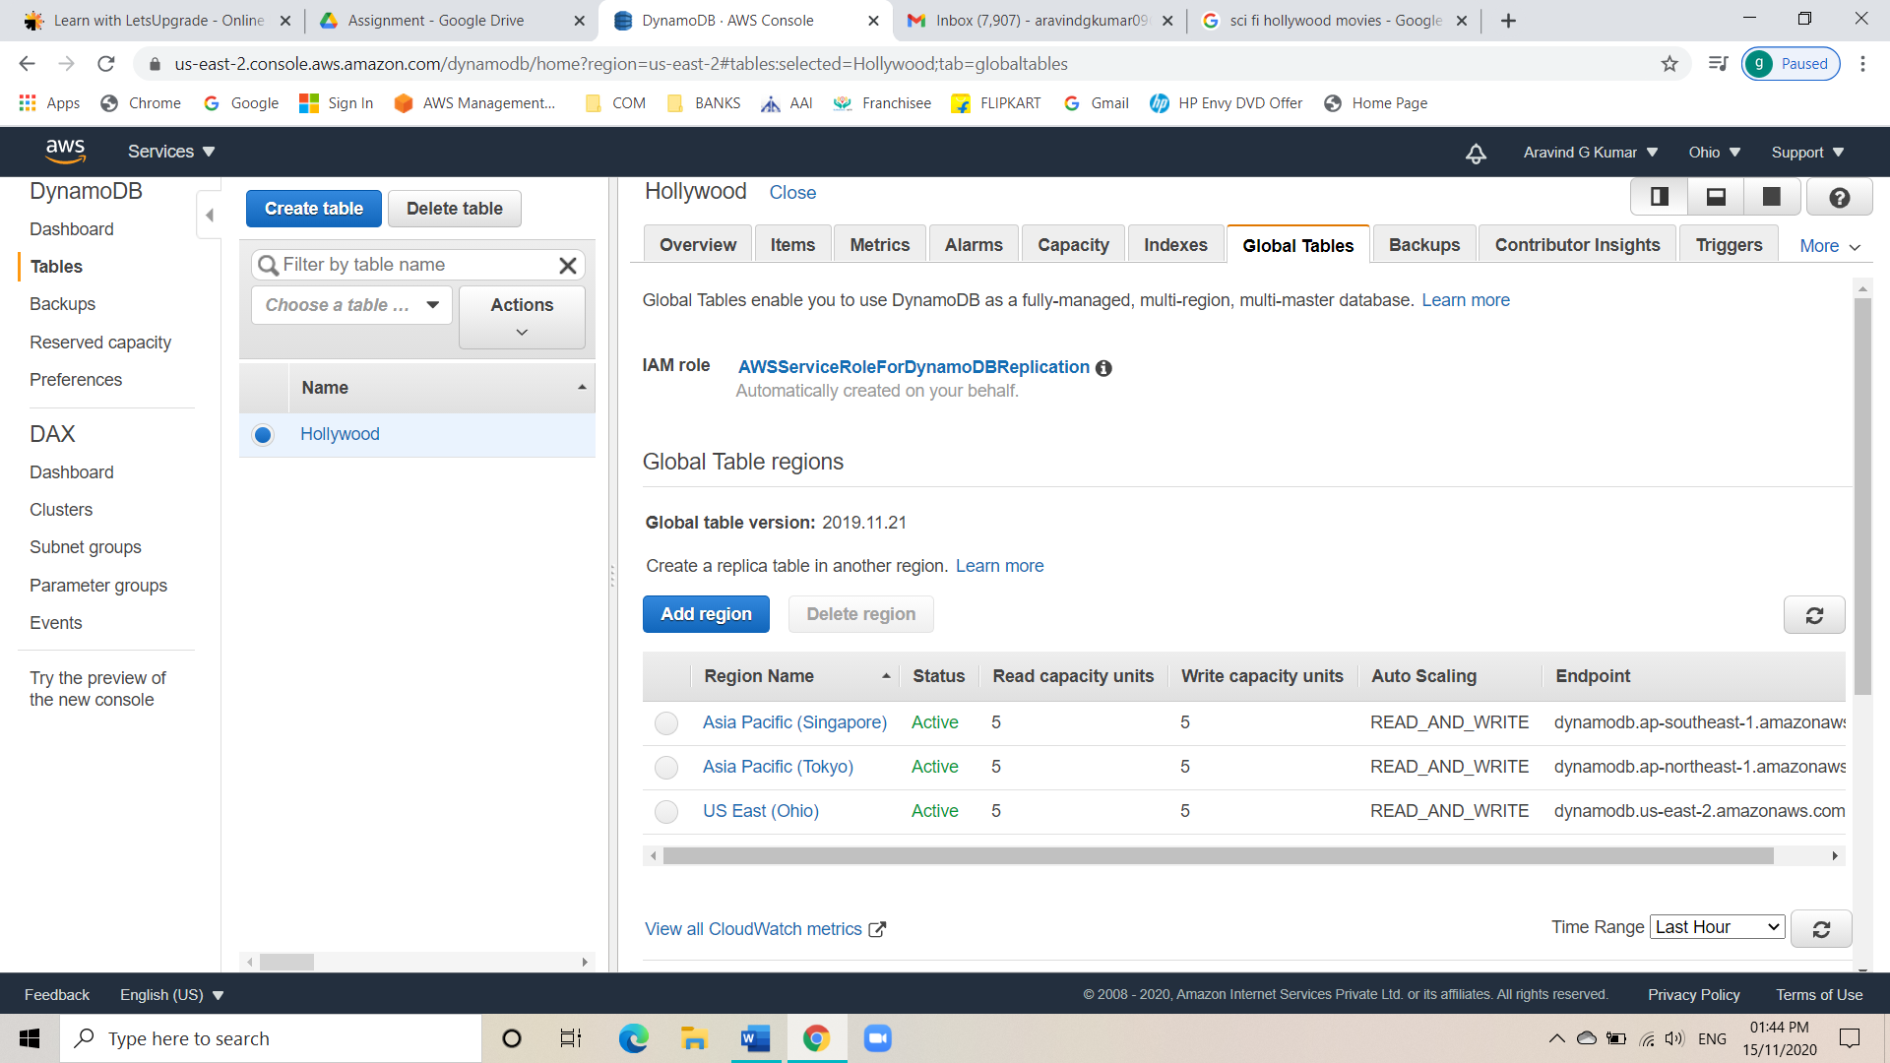

* See whether they are reflecting.
* AZ1.

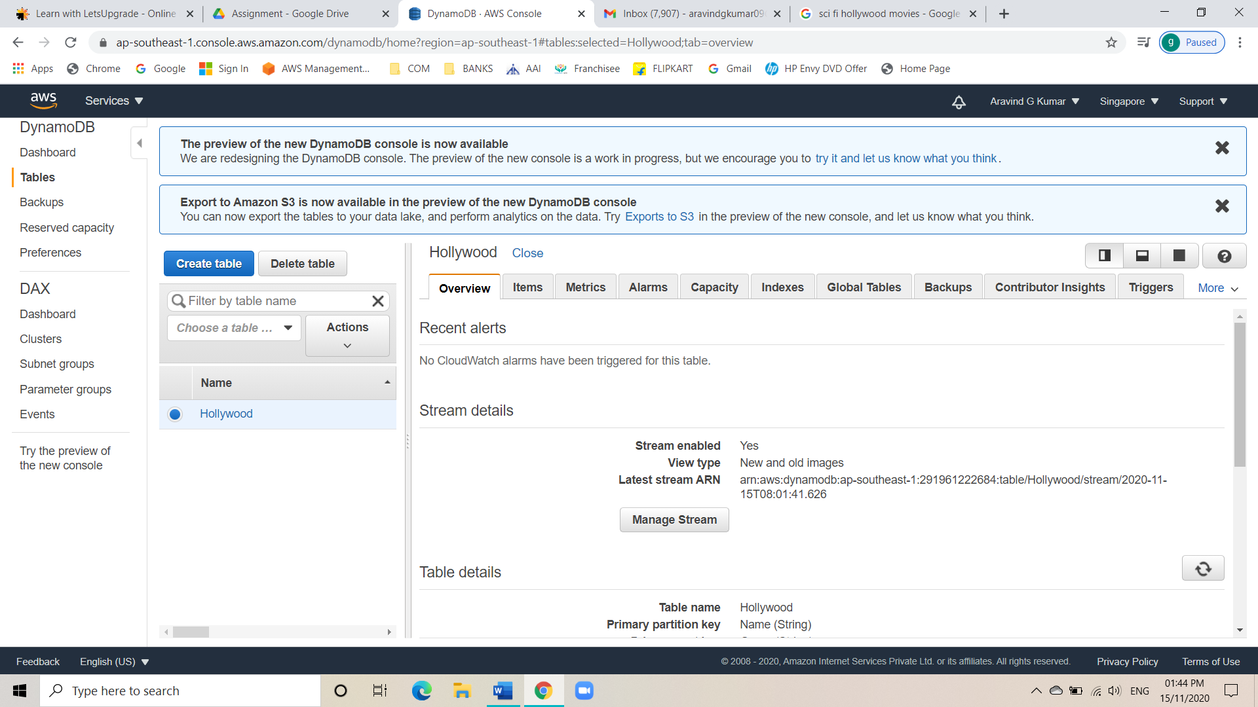

* AZ2.

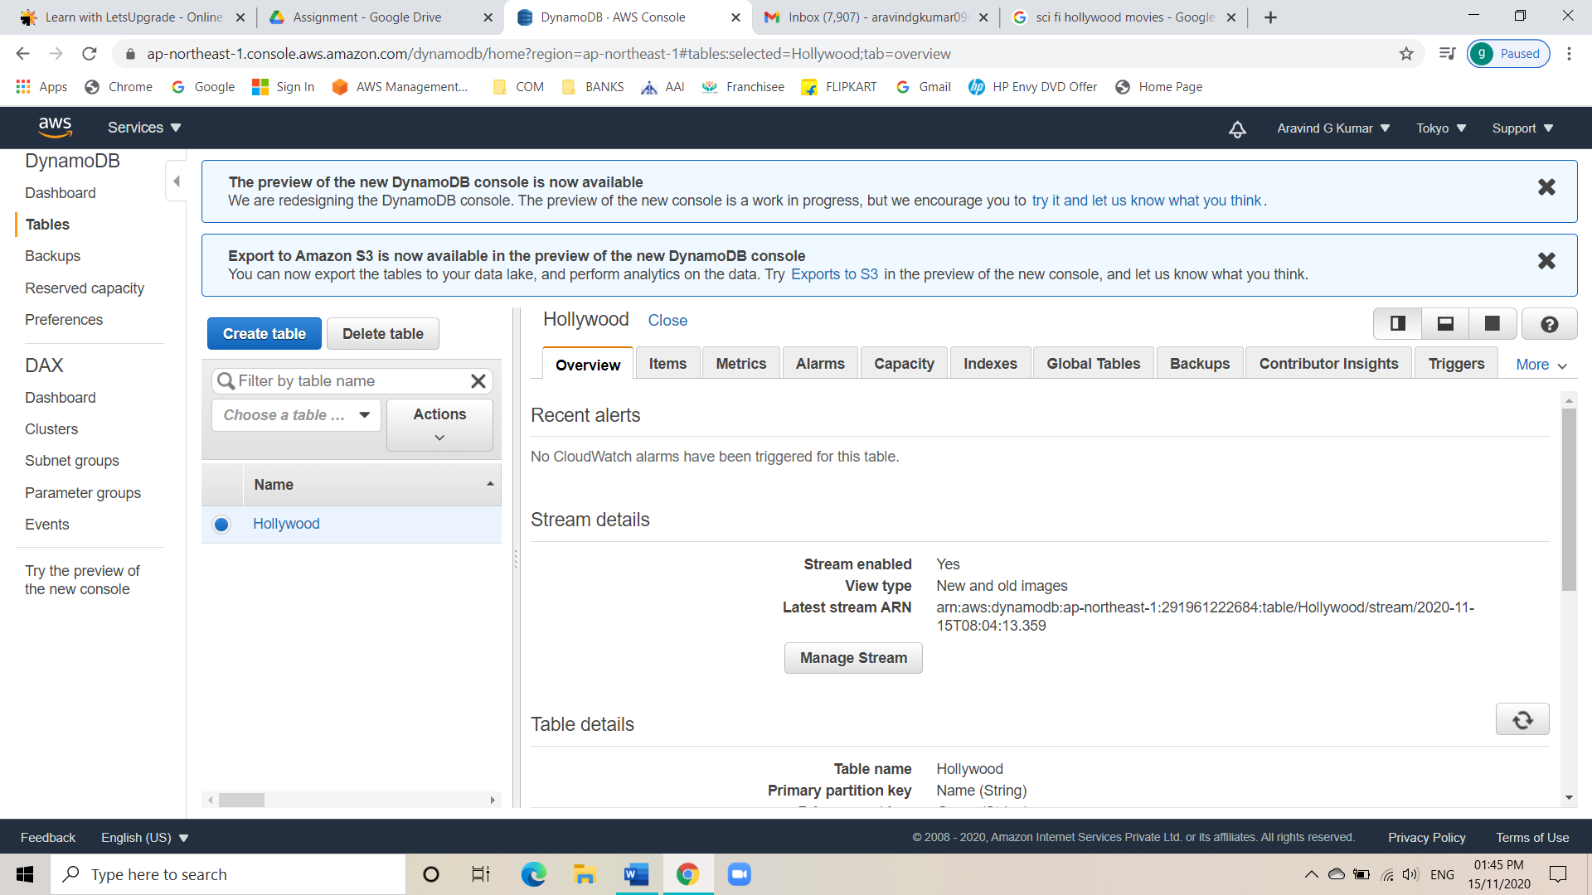

* Go to items and create items.

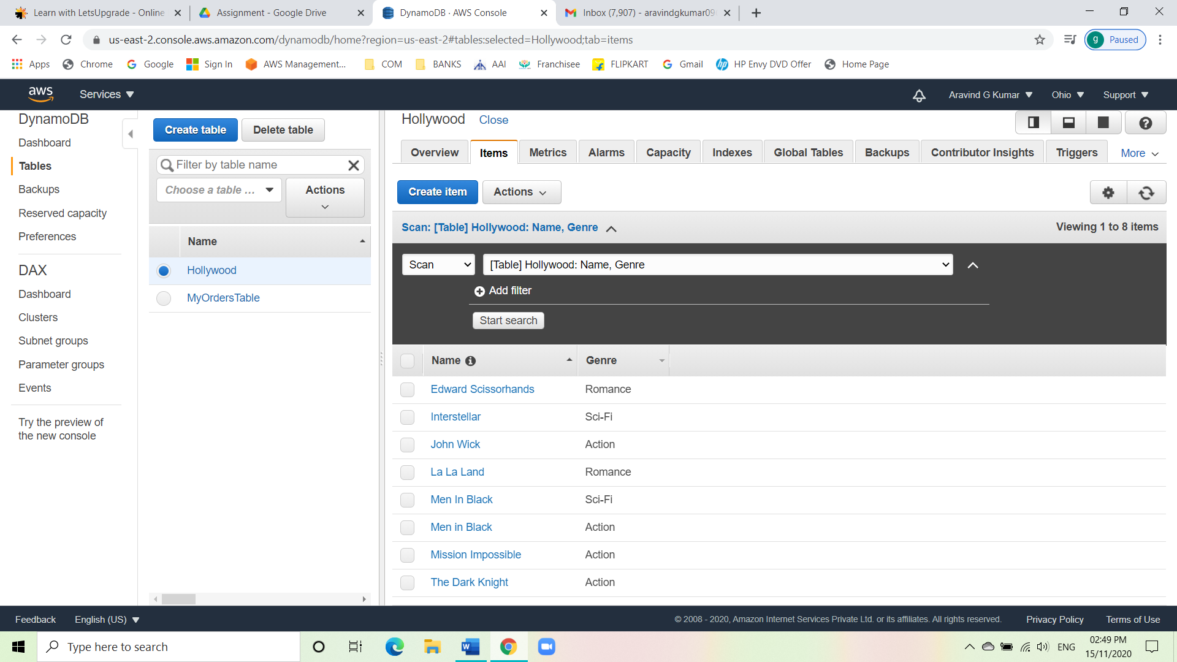

* Use query to fetch the items.

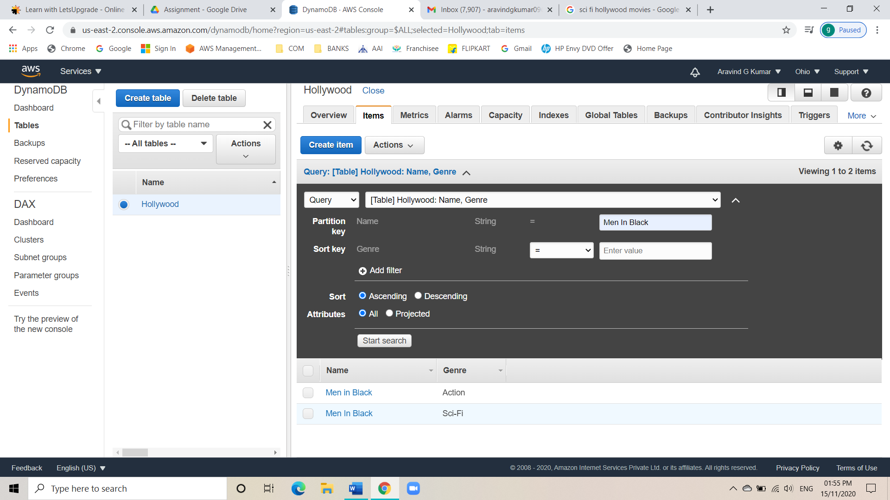

* Delete an item and verify.

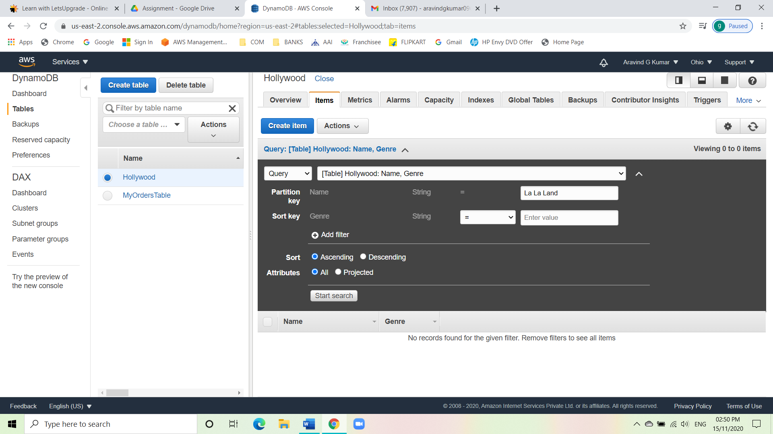

Task 6: Creating a dynamo DB table with global secondary indexes and fetching data using global

secondary indexes.

* Create another table.
* Add an item.
* Go to indexes.
* Create a global secondary index.
* Create more items one for local and other for global.

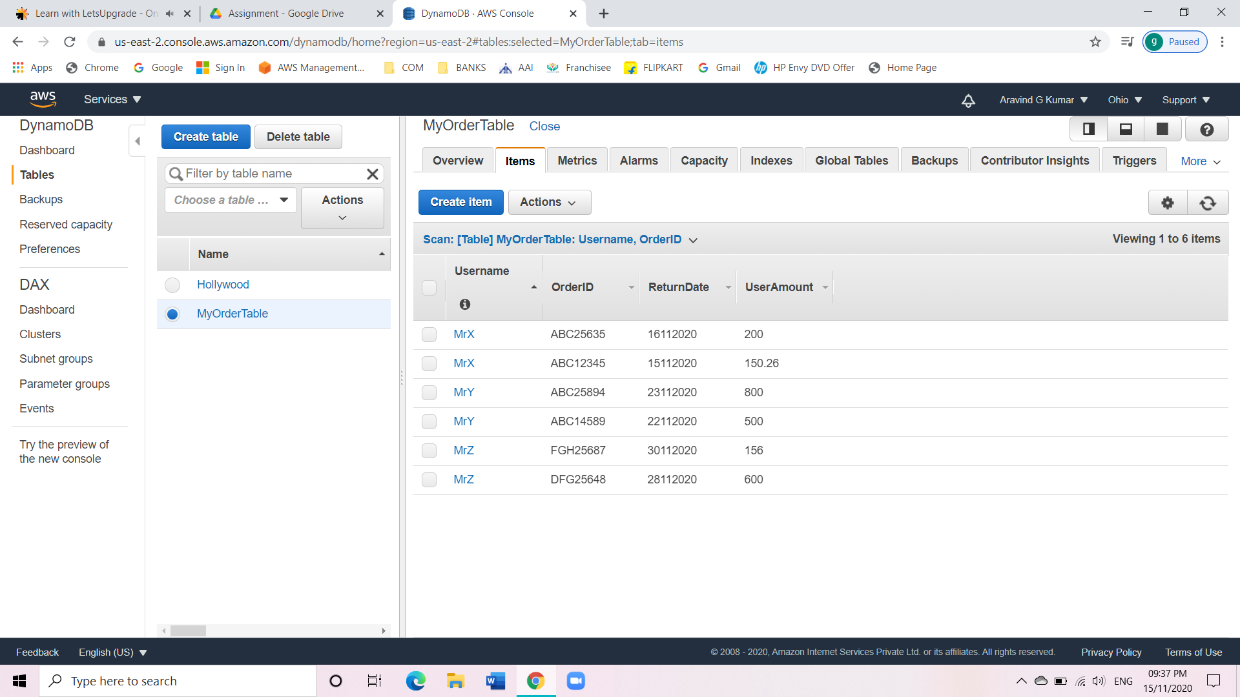

* Scan it with GSI.

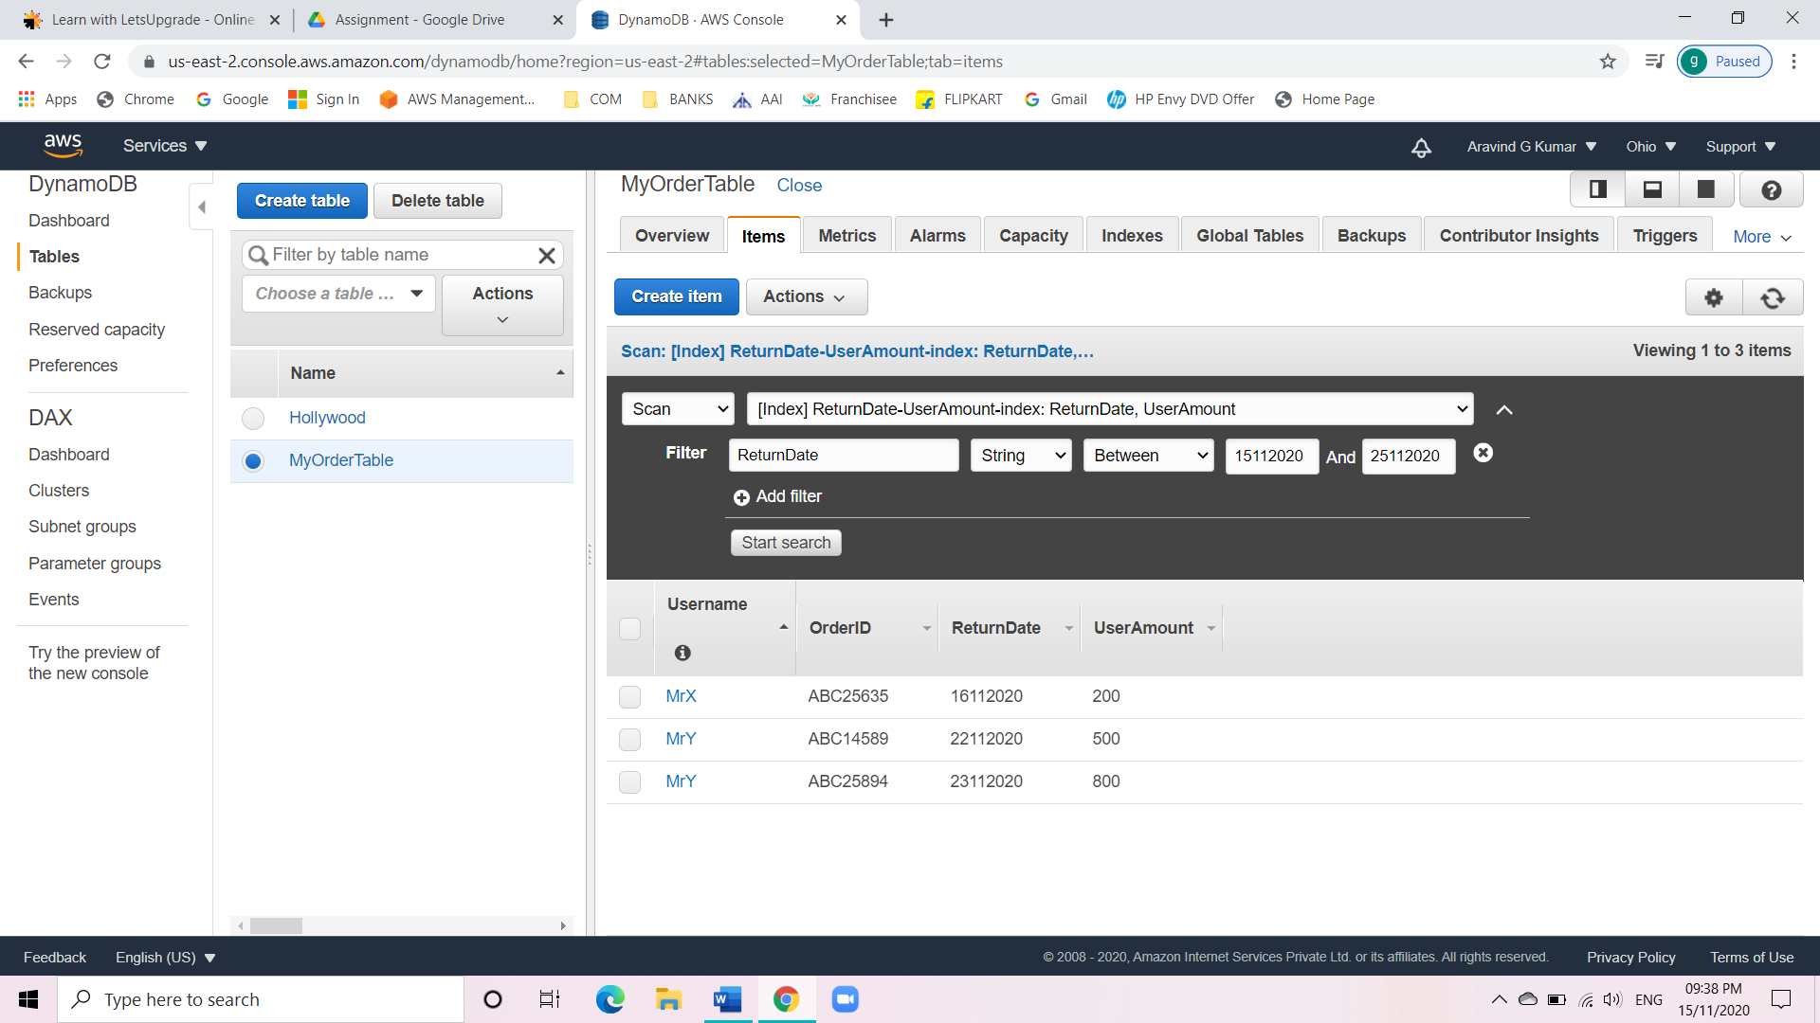

Task 7: Deploying a python application in elastic beanstalk

* Go to elastic beanstalk.
* Click on launch an application.
* Choose a python environment.
* Check for the health of the environment.

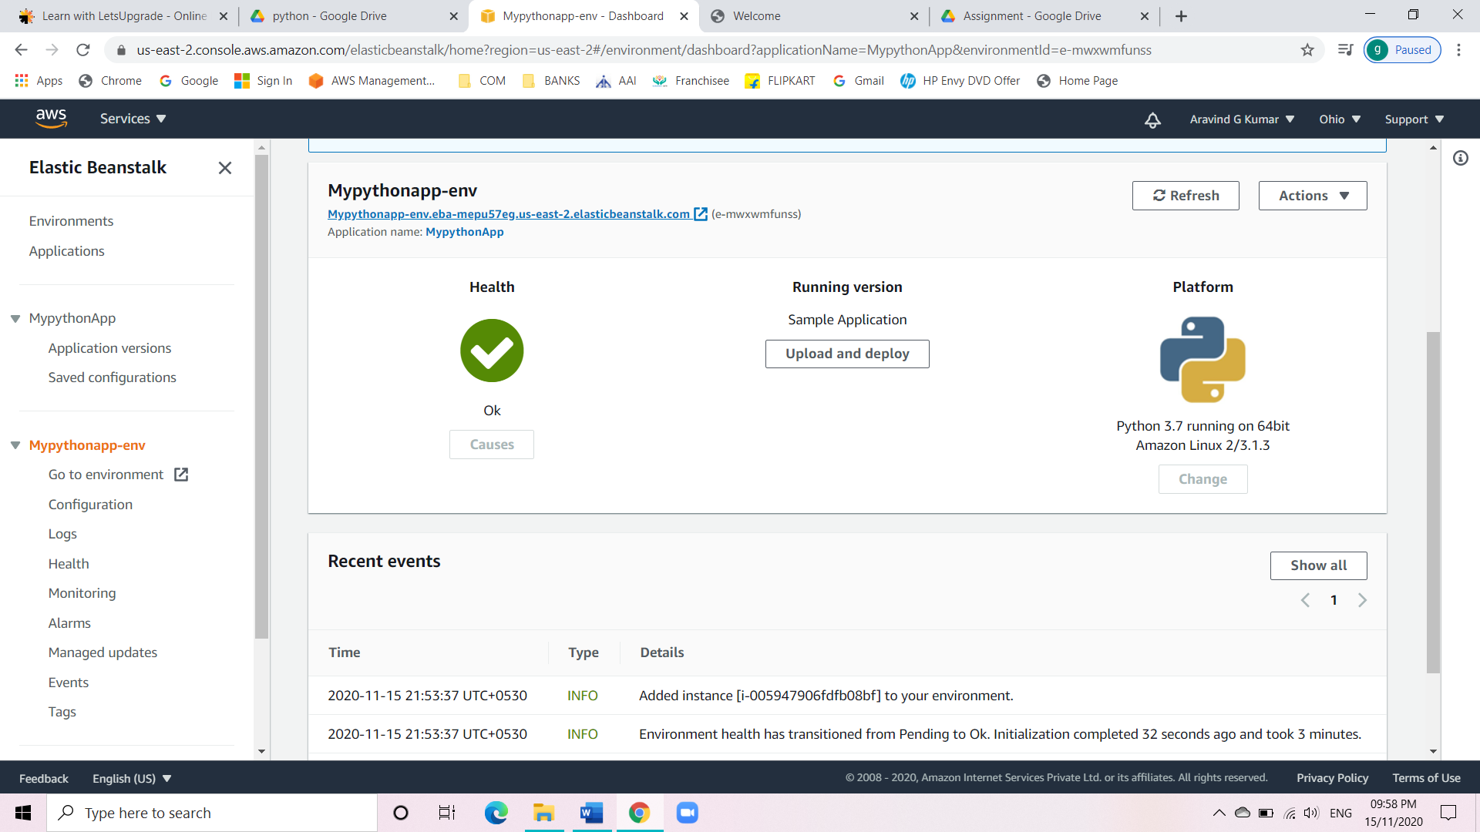

* Use the DNS to connect to the website.

